|  |  |  |
| --- | --- | --- |
|  | Faculty of Information Science And Technology  Universiti Kebangsaan Malaysia  43600 Bangi  Selangor | |
|  | | |
| **Project Title:**  Homestay Rental Application (HomeRA) for UKM Students | | |
|  | | |
| **Lecturer:** <Lecturer’s name> | | |
| **Group Members:** | | |
| CHEN HUI XUAN | | A160687 |
| LIM ZEE HIN | | A160592 |
| KIM SAY LIANG | | A161114 |
| LOO XIN YONG | | A160195 |

**TABLE OF CONTENTS**

1. **INTRODUCTION**
   1. **Problem Statement**

Online booking is a very common service that we frequently use nowadays. Online booking system has boost the quality of the service industry such as hotel, flight, restaurant and others. Some of the students from Universiti Kebangsaan Malaysia(UKM) failed to get their room in dorm due to various reason and they have been force to search for a place of living outside the UKM. They can share the homestay together and distribute the rental fee to lessen the burden. Therefore, our team decides to develop an application which can ease the people in UKM to rent a homestay via online booking. The main function for this application is to provide online homestay rental service to UKM students. Due to the location factor, area around Bangi is the focus for the homestay because it is near to the campus of UKM. The main functions of the application will be searching homestay, comparing the price and type of the homestays and reserving homestay for UKM students while the administrator /admin (homestay owners) will be able to record the payment of the homestay reservation. Our target users are UKM’s students and homestay owners in Bangi area. Each of the homestay owner are registered in the system along with their homestay address, homestay type and rental price while customers (UKM students) do not register.

* 1. **Proposed Solution**

**1.2.1 Name of the system/application**

Homestay Rental Application (HomeRA)

**1.2.2 Functionalities and Developers**

1. Search homestay (Chen Hui Xuan - A160687)

This function will be the main function for the application. This function will be targeted to be used by customer users consisting of UKM students looking for homestay near Bangi. Customer users will be able to search homestay that is registered in our system by categories. They can search homestay by name, address and type as there will be homestay of various type and location (in Bangi area) available for reservation.

2. Compare homestay (Lim Zee Hin - A160592)

This function allows customer user to find their perfect homestay by comparing their price and type. User can choose the comparison type and view two of the chosen homestays. The user then able to compare the homestays after the details for both homestays showing up.

3. Reserve homestay (Kim Say Liang - A161114)

After the customer user has done searching and comparing the homestays, the users can make reservation. Customer will need to fill in details of reservation like the selection of homestay and the month. Each homestay can only be reserved for a month and the availability is shown. Customer does not need to pay upon reservation through the system. They will only need to pay when they walk in to an available homestay and check in straight away or when they check in with their reservation. The owner of the homestay will record the payment.

4. Record payment (Loo Xin Yong - A160195)

This function is used by admin user which is the homestay owner to record the payment. The owner will record payment for two types of reservation which is new reservation for walk in UKM students and existing reservation which has been made by using the system. For a new reservation, the owner need to complete the form with the reservation details including homestay ID, customer ID and the month for reservation. The availability and payment status is shown too. On the other hand, when owner record payment for existing reservation, the details of reservation is shown. After the owner recorded the payment, the payment status of the reservation will be updated.

**1.2.3 Users**

1. Customer (UKM Students)

UKM students including PERMATA students to PHD students will be able to make their homestay reservation through the system. Many UKM students are forced to search for a home outside of the campus due to the lack of place in residential college. Therefore, they can use the system to book a homestay to stay temporary while they appeal for their college.

2. Admin (homestay owners)

Only selective homestay owners can use the homestay reservation system. There is not registration function in the system to register a new homestay owner in our system. This is because selective homestay owners that collaborate with us is already registered in the system.

**2.0 USE CASE**

**2.1 Use Case Diagram**

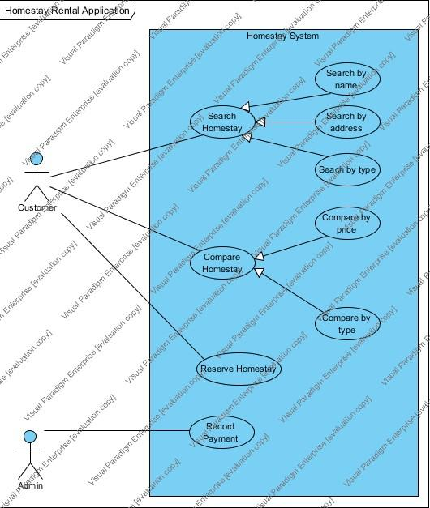

**2.2 Use Case Specification**

1. Search Homestay

|  |  |  |
| --- | --- | --- |
| Use Case ID | UC-1 | |
| Use Case Name | Search Homestay | |
| Primary Actor | Customer | |
| Pre-condition | Member is authenticated | |
| Post-condition | Compare homestay facilities and price | |
| Main Scenario | Customer  1. Customer enter member ID.  3. Customer enter homestay name.  5. Customer enter homestay address  7. Customer enter homestay type. | System  System check whether member’s ID is valid.  2. If Customer ID is VALID, system process to search homestay, else system display error.  4. if homestay name is VALID system display the homestay, else display error.  6. if homestay address is VALID system display the homestay, else display error.  8. if homestay type is VALID system display the homestay, else display error. |

1. Compare Homestay

|  |  |  |
| --- | --- | --- |
| Use Case ID | UC-2 | |
| Use Case Name | Comparing two homestays | |
| Primary Actor | Customer | |
| Pre-condition | Customer is authenticated | |
| Post-condition | Back to the Main Menu | |
| Main Scenario | Customer  1. Customer selects “Compare Homestays”.  2. Customer selects the “Compare Type”  6. Customer selects the “Type of homestay”  8. Customer selects the first homestay to compare  10. Customer selects the first homestay to compare | System  System displays “Compare Homestay Screen.  System asks customer to select the “Compare type” to be compared.  3. If “By Price” is selected, system display the “Compare by Price Screen”  4. Else if “By Type” is selected, system display the “Compare by Type Screen”  5. Else “Back” is selected, system return to main menu.  7. If the selection is VALID, system display the homestay that match the selected type.  System ask customer to select the first homestay to compare  9. If the selection is VALID, system displays the details of first homestay selected.  System ask customer to select the second homestay to compare  11. If the selection is VALID, system displays the details of second homestay selected. |

1. Reserve Homestay

|  |  |  |
| --- | --- | --- |
| Use Case ID | UC-3 | |
| Use Case Name | Reserve Homestay | |
| Primary Actor | Member | |
| Pre-condition | Member is authenticated | |
| Post-condition | Customer reservation for homestay | |
| Main Scenario | Member  1. Member enter Customer ID.    3. Member select the homestay ID option.  5. Member select the customer reservation month option.  7.Member click “Submit” button. | System  2. System will auto-generate the Reservation ID.    4. System will display the homestay ID option.  6.System will display the customer reservation month option.    8. System records customer reservation details. |

1. Record Payment

|  |  |  |
| --- | --- | --- |
| ID: | UC-4 | |
| Use Case Name: | Record Payment | |
| Description: | Homestay owner receive cash from customer. Homestay owner log in to the system to record payment to complete the transaction when the customer walks in for reservation or rental. | |
| Primary Actor: | Homestay owner | |
| Preconditions: | Homestay owner is logged in and has available homestay for rent | |
| Postconditions: | Customer check in the homestay | |
| Scenario:  Extensions: | Actor | System |
| 1. Owner selects “Record payment” from the menu.    3. Owner selects reservation type.  5. Owner fill in details and/or record payment  6a2. Owner choose another homestay or/and month.  6b2. Owner enter valid customer ID. | 2. System displays options whether owner wants to record payment for existing reservation or new reservation.      4. System displays reservation information and payment information.    6. System records the payment and the payment status of homestay is updated.  6a1. System display message that homestay is unavailable. User is required to choose a new homestay or new month.  6b1. The customer ID is not valid |
|  |  |  |

1. **DOMAIN MODEL**

3.1 System/Application Description

The system is used by homestay customer and owner. The information of existing customer and owner is stored in database. These customer and owners who are already stored in database are considered registered in our system. Being registered in our system enables them to login to our system and carry out tasks like searching homestay, comparing homestay, make reservation and record payment.

After login to the system, customer can search homestay by searching the homestay by their name, address and type. For searching homestay by name and address, uer will key in the homestay’s full or partial name or address. The system will search through the database and display the output that matches the user’s input. The function of searching the homestay by name will help customer to search for the homestay if they already know the name of the homestay while the function of search by address will help the customer to find their desired homestay based on the location. Searching the homestay by type also enable user to find their type of homestay.

After searching the homestay and comparing, the customer can reserve their desired homestay. They need to know the homestay ID to proceed their reservation. The system only allows user to make reservation of available homestay. The payment for reservation cannot be done in the system. It has to be done by paying cash to the homestay owner and the homestay owner will record the payment by using the system.

As for homestay owner, the system is also very simple to use. The owner just have to update the payment status once they receive cash from customer.

3.2 Domain Model

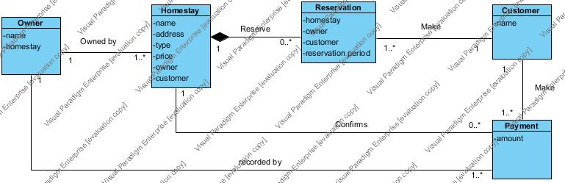

**4.0 SYSTEM SEQUENCE DIAGRAM**

The diagrams below shows the system sequence diagram for searching, comparing, reserving homestay and recording payment.

4.1Search Homestay

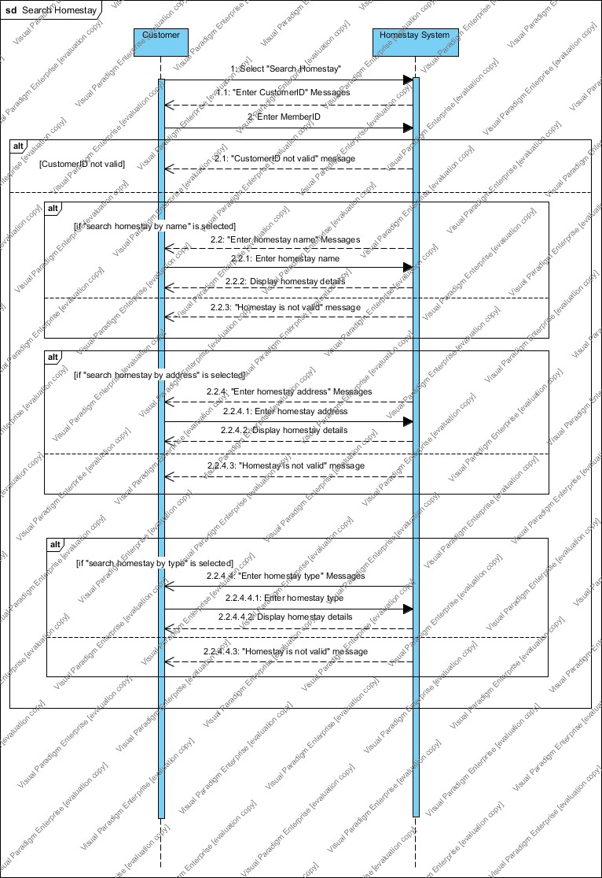

4.2 Compare Homestay

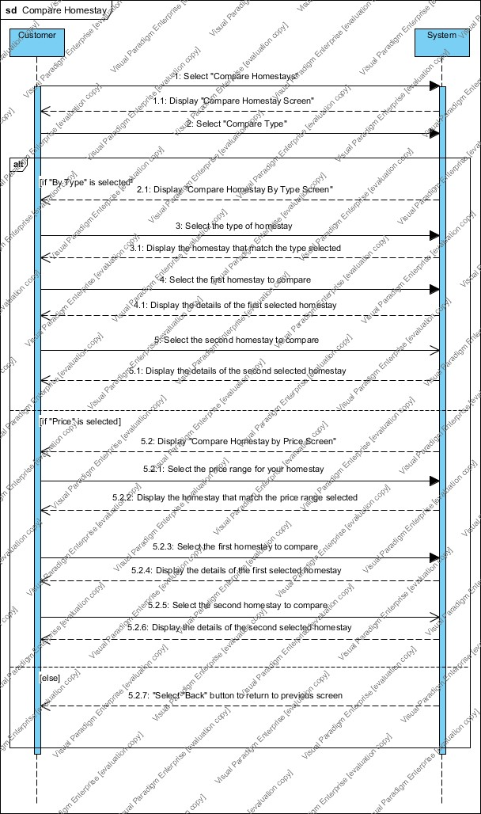

4.3 Reserve Homestay

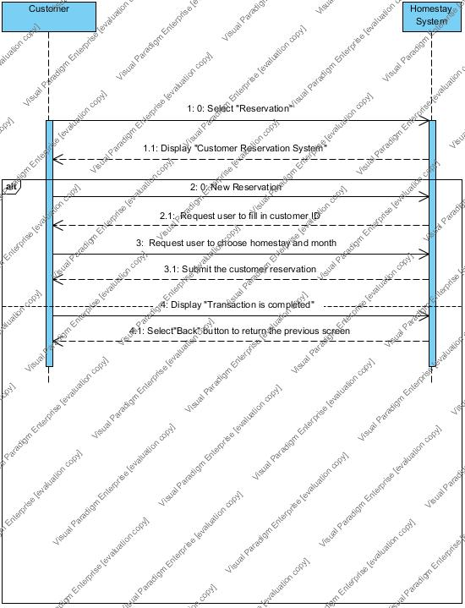

4.4 Record Payment

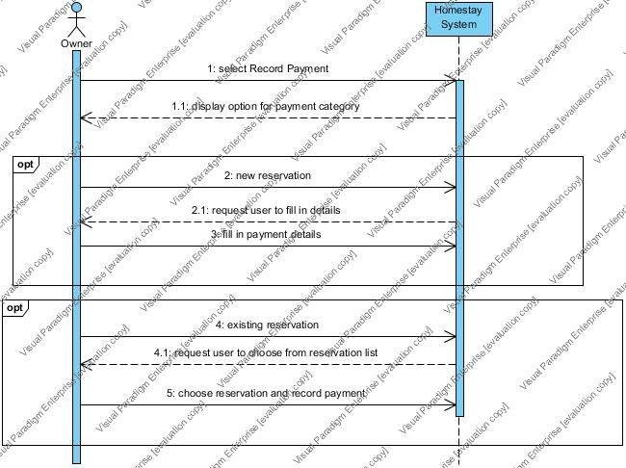

**5.0 OBJECT SEQUENCE DIAGRAM**

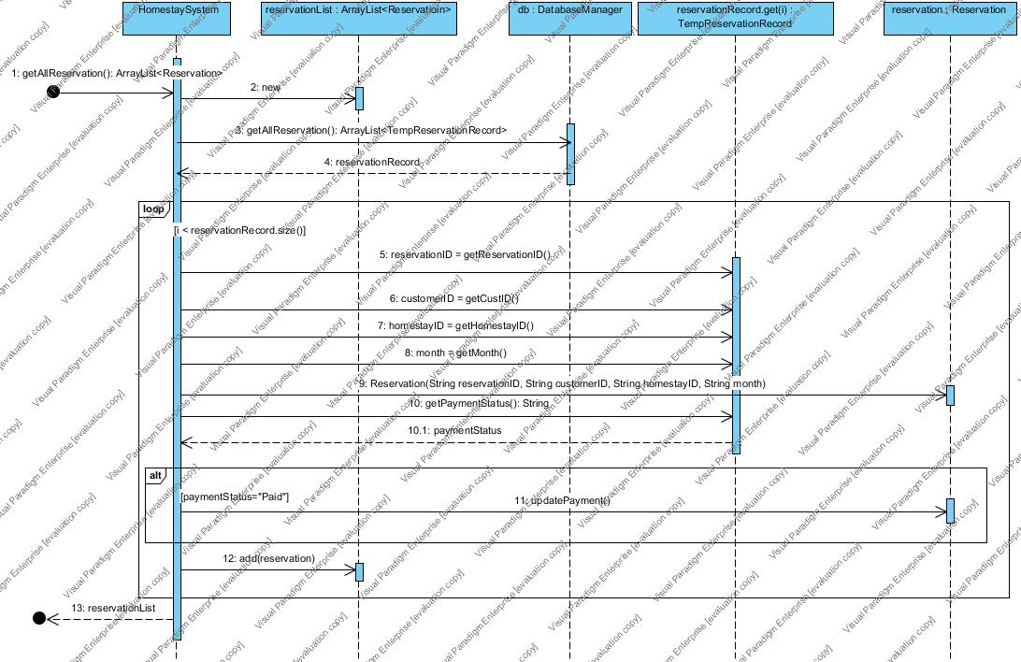

**6.0 DESIGN CLASS DIAGRAM**

**7.0 DISCUSSION**

7.1 Development of Proposed System/Application

To develop this system we followed the Software Development Life Cycle (SDLC). The SDLC model we are using is the **Waterfall Model** due to our sequential phases in developing the system and project scope is clearly defined and small.

1. Requirement gathering and Analysis

Homestay Rental Application (HomeRA) is a system to let the UKM student to search for a homestay for them to stay. Targeted user is UKM students and Use Case Diagram is drawn to show the user and their respective task that they will carry out by using our system. The required data for system are the details for the homestay (name, address, type and price), details of the homestay owner (name, ID and password) and the details for customer (name, ID, password, reservation).

System Requirements Specification:

1. The application should let the customers to view the homestay available around Bangi.
2. The application should let the customers to search the homestay by its name, address and type.
3. The application should let the customers to compare the homestay by its price and type
4. The application should let the customers to reserve the homestay by month.
5. The application should let the admin to record the payment made by customers.

**Use Case Diagram** is drawn to show the interaction between homestay system and its user (*admin* and *customer*). Since there are four functionalities for the system, therefore **four use cases** and its **use cases specification** are created.

There are 2 actors involved in the use case which are *admin* and *customer*. The system boundary is the homestay system. Three of the main functionalities which are search homestay, compare homestay and reserver homestay are associated to *customer*. The last functionality is record payment which is associated to *admin*.

The use case specification used is **fully-dressed** to show the most details of each of the main function.

The domain model is visual representation of conceptual classes or real-world objects in a domain of interest. It is illustrated with a set of class diagrams in which *no operations* are defined.

2) Design

System Sequence Diagram (SSD) for each functionalities are drawn to show the particular scenario of the use case , the interaction between external actor and a system. Four SSD were drawn to satisfy the four use case specification.

There are 3 common layers in our system logical architecture which are:

1. Data Layer (Lower Layer)

* Data layer consists of database of the Homestay Rental Application system.
* Database stores the details for homestay, homestay owner, customer and reservation.
* Implemented in data package in Eclipse

2) Domain Layer/Business Logic Layer (Middle Layer)

* The four main functionalities are implemented in this layer (Search homestay, Compare homestay, Reserve Homestay and Record Payment)
* Implemented in logic package in Eclipse

3) Presentation Layer (Upper Layer)

* The system is presented to the user through the presentation layer
* User interacts with the Graphical User Interface designated by developer
* User input or interaction will call the services from lower layer
* Implemented in ui package in Eclipse

Object Sequence Diagram (OSD) for the most complex functionality is drawn to show the interaction between objects.

The getAllReservation function in has been chosen for the OSD as it’s the most complex functionality Customer has to make reservation for the homestay by reserve homestay in the Reserve homestay UI.

Design Class Diagram (DCD) also drawn to illustrate the classes, interface and their associations in the system. Operation and method for each classes are shown. DCDs are usually created in parallel with interaction diagrams. Many classes, method names and

relationships may be sketched out very early in design by applying responsibility assignment

patterns, prior to the drawing of interaction diagrams. It is possible and desirable to do a little

interaction diagramming, then update the DCDs, then extend the interaction diagrams some more and so on.

3) Coding and Implementation

The entire design was broken into modules and code for each module is written by each member before integrating the modules into one system. The modules separated by user tasks including searching homestay, comparing homestay, reserving homestay and recording payment.

Eclipse is used for the coding and implementation phase.

i) Each of the functionalities are distributed to our team to work on

ii) Most of the logic is implemented in logic package

iii) Each of the developers also work on the GUI of each functionalities.

iv) The modules/functionalities are then integrated into a system.

4) Testing

The system is tested by developer for a various time and any possible errors are eliminated to prevent compilation error and logical error. Below are the testing executed.

- System testing

- System Integration Testing

- Usability Testing

The system is tested repeatedly to look for software bugs to make sure that the system is fit for use and meets the requirement of the users. It is also tested to make sure that it responds correctly to the input and performs function within acceptable time. Integration testing is also carried out to verify the interfaces between components against a software design. The defects in the interfaces and the interaction between modules is found through integration testing. Each module is integrated and tested progressively until the software works as a system. Lastly, usability testing is carried out to check whether the user interface is easy to use and understand. It will ensures that the users will be able to perform tasks as required.

5) Deployment

The Homestay Rental Application System is then deployed for customer at the customer’s site for testing. The java file in Eclipse is exported as a runnable jar file. A .bat file with “java -jar (filename).jar” is saved in the same directory as the .jar file to help to execute the .jar file by double clicking on it. The folder with the .jar and .bat file is distributed to users for testing. User just need to double click on the .jar file to execute the program. Alpha and Beta testing feedbacks and issues are reported back to developers team to ensure they address them sooner or later before the final release.

8.0 System Demonstration